EPS FINAL PROJECT PROPOSAL

-Padma Venkatraman

TITLE: Ants go marching

TOPIC: Simulation of how ants are able to form pheromone-based tracks and thus optimize their path to their food over a period of time.

GOALS:

1. Implement a modified Ant Colony Optimization Algorithm in Python based on random walks.
2. Simulate the releasing of ants into a space and give them a goal (food) and demonstrate how the path they all take over a period of time the ultimately the shortest path.

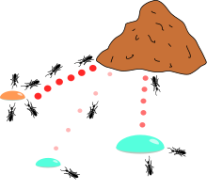

1. Demonstrate how the path taken by an ant before affects the decision of the next ant.

2) What simulation method will you use (ODE, PDE, molecular dynamics, random walks etc.) ?

I will use random walk with probabilities determined how much pheromone an ant released, paths taken by previous ants and the weight assigned to each edge. The probability is determined the formula given below.

3) What will your animation show?

My animation will show a bunch of ants being continuously released at random points into the graph and it will demonstrate how their movement evolves over time.